Lets suppose we want to do it Lets not talk about big budget we have normal budget a business operate around small radius like 2,4,5 km. For example coaching which work in a small area Can we do this for that can we do clean sweep there can we dominate in a particular topic in that area if we can do it then how to do it. We will discuss in our lesson

Here we need to assume that the people we need to target people who have interest in Government Jobs or who are graduate Here our business is coaching which give teaching in UPSC and SSC. This type of coaching can exist which locate in a specific area. So it is a geographically limited business here we are assuming it because there is no coaching which is geographically limited as you can see digital Marketing is popular nowadays

You can see nowadays coaching have youtube. But still for our example we are tal=king an example it want to target around 10 km of it. Can we do this if yes then how to do it.

O first you need to accept that you need to keep budget heavy here . you need to keep thid thing in mind . you need flexibility in your budget it will not happen that wih limited budget you can achieve many things here this is not possible you need a proper budget here then only you can clean sweep properly here and don’t assume that clean sweep percentage will be 100 don’t assume you will be able to do 100 percent clean sweep you will be only able to reach only 60 to 70 percent people assume it in starting Now we try to understand the system Lets asuume whatever area we are targeting lets say 10 km area the intereset we pick of UPSC aspirant and graduate are 1000 in number hypothetically and they are interested in Government Jobs

And these 1000 people interested in government Jobs How the Facebook system will identify them you try to understand it. He event divide these 100 people in different categories because these 1000 people have different interaction in Facebook. Some people do interact with the Govt Job coaching ads and there may be some people who have already done the coaching and some just see the ad and move on and some people go to landing page and fill the form and take demo class these different activity these 1000 people are working signal goes to Facebook on the basis of what their interaction or behavior on ad

We can divide these 1000 people into traffic where the people click on the ad and visit landing page So facebook classify it to say that there are chances that if these people show some coaching related ad the chances are that by engaging with the ad they will go to landing page suppose such type of people are only 50 percent and the next 20 percent classify the people who have higher chances of engagement because they have done engagement earlier like share, like etc and they have high probability that they will do the engagement Facebook is getting the signal that these people are interested in the targeted topic and they can also do engagement to ad related to topic

We have two sides one is Audience side and another is Advertiser side here I am assuming it because when we get the chance to run ad then yo have to choose the objective

So we say among 1000 people there are some people who will do bring traffic to landing page and there may be some people who will bring engagement and then there will be people who can bring convergence here like form fill as they were behaving that they will do convergence.

**Phase 81**

We are advertisers and our main purpose is to clean sweep all these 1000 people and we assume there is no problem of budget here. Now how will it happen Lets say hypothetically we keep the budget 1000 rupees So when we make campaign then It will ask the objective now we keep the objective traffic

Now after choosing traffic objective campaign there are 50 percent people who have a possibility that after clicking on the ad they will reach the landing page So the way Facebook is designed it will try to target these 50 percent people only. Because I have said to Facebook before hand that 1000 rupees is my budget and I want that there should be traffic in my landing page so who will our Facebook show the ad to traffic or Engagement or convergence Of course Traffic Now when I run the ad it can happen that out of 50 percent we cannot cater all the people people may be cater 10 percentage of it

Now if we increase the budget gradually then we will see that in this 50 percent audience set the percentage that the will reach the landing page will increase with the budget it can happen that this 10 percent id now 40 percent

Now we suppose there are 1000 people the 50 percent will be 500 people who have higher chances to bring traffic So 10 percent of 500 will be 50 Now budget is increased and then we increase the budget then this percentage will be increased that’s what we are talking about that if we want to dominate a particular niche we have to make up our mind that we have to put the budget we are increasing due to which we can cater this 50 percent or 500 people Still we are not able to cater Engagement or convergence the potential is still missing It is not like we are able to clean sweep even if you keep increasing your budget then you will show your ad to these 50 percent or 500 people repeatedly Now even you have high budget the ad is being shown to them repeatedly due to which frequency is increasing In facebook ad frequency is a very important thing your frequency is increasing ad you cannot reach to the Engagement and Convergence audience

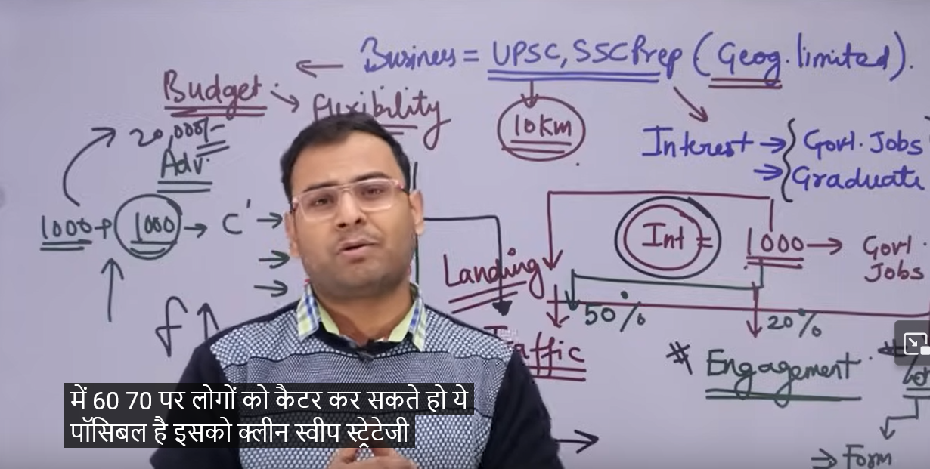

If you are in a specific area you are targeting a particular category or niche or interest want to dominate 60 or 70 percent then the budget is not only the way budget you need to touch different campaign objective budget is important but it is also important Such situation happens in practical life when for your business and client business you run the it will not happen that this situation will happen and it is possible even if you have very large area to target we will have very big challenges but for small area we can handle it and can cater to 60 to 70 percent people we call it clean sweep strategy but the primary things to check that the location is limited then we can implement domination strategy there is no problem of budget yes we can implement the domination strategy check these two thing and move forward where you will get stuck if you stuck only in one campaign strategy then the potential around this campaign you will keep showing them ad repeatedly and you will not be able to show the ad to the rest so try to understand from your self

In facebook ad there is no system that by clicking it that everything happens automatically we have to make strategy ourselves we have to test these strategies and we have to do many thing

**Lesson 63:-**

In this lesson we will learn about **Creating eCommerce Events in Facebook**

Setting Ecommerce or setting ecommerce based campaign setup means the sales related to

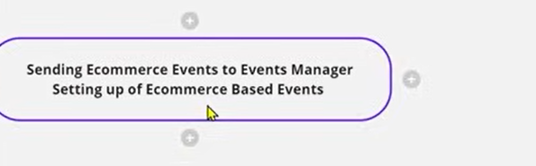

Setting Our catalogue sales related ad it is like setting ecosystem in our facebook ads

It is not like that that the way we start our traffic ad campaign. It is not like that when we run catalogue sales ad or we have some ecommerce website and then related to it when we want to run our campaign then we have to setup many things beforehand if we talk about important thing we have to see the ecommerce based events that they are properly set up whether we can see it in our event manager or in pixels and then we have to check that our product catalogue so these 2 or 4 things are very important that we need to keep in mind then we can run our ecommerce Based ad or our catalogue ad .Here complication increased because the event setup in Wordpress website is different in Vix website we use different event and in squarespace there is website then we will do by different events. Ad if there is another custom website made in another CMS then we use different ways to setup event and other things

What we are saying there are different things when we want to run our catalogue sales ad. So it is very important that we study everything one by one

In this lesson we are going to talk about how to set our ecommerce based event in our event manager or in pixel we can setup

What are Ecommerce event

We can see that below is Teachers demo website

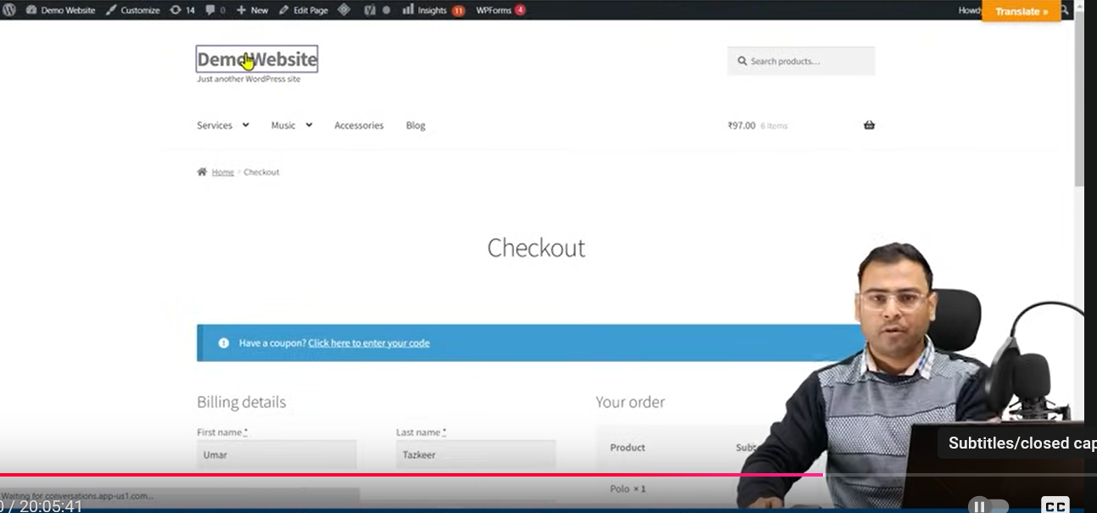

And when you run ad in facebook for a website after creating ad account the next step to do is to setup pixel in our website so that you can track the interaction on the website in your pixel and n the basis of that you can further make audience and do optimisation and you can run conversion based campaign.

Connecting pixel to the website is an important thing

After making ad account you do this After doing this we also set up our event We can make an event that that track hen some one reach thank you page and on the the basis of these event we run convergence campaign and do optimization same things go for oue ecommerce website also

In normal website we have custom events which we set according to our requirement if we talk about basic event that is page view

Whenever you set pixel on you every page then that view is counted when that page is loaded

This is the basis event that is fired in any website but here if we talk about Ecommerce events

These are another type of events

Suppose you load normal website especially in chrome The facebook pixel helper tells you that

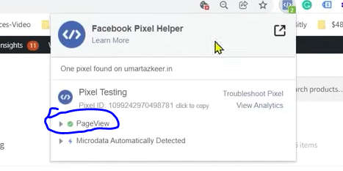

**Phase 82**

The facebook pixel helper will tell you that pageview happened as marked above These things are captured and these information are going to pixel one pageview happened

Now if I click on the product

Then new page is opeded you see it is still recording pageview

Now we click on add to cart button as marked below

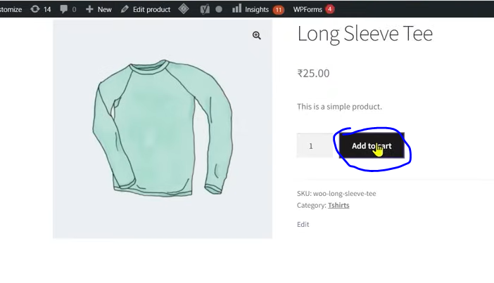

Now even after you checkout the main event is still page view event

What we are saying that pixel cannot understand that the user is in checkout page or checkout event happened

For Ecommerce website we have different ecommerce website

If we talk about types of events in Ecommerce

First is View Content , then comes add to cart then comes the checkout event then comes the Payment or Order Complete or Sale event

View content is when someone open the product page

And Add to cart happen when ass to cart url got hit.

And the checkout happens when you checkout

There can be another events but majorly these events are present

If you can view the event of a normal page when can you not see the events of ecommerce yes you can. How we fomr Ecommerce events Our pixel Checker will read that checkout happened here.this checkout event happened information will go to our Event manager

In Event manager we can see how many add to cart happened ,View content happened that’s why it is important that is you have ecommerce website when we need to setup our Ecommerce events

We will see how technically we can set up we need to understand it

When we talk about setup then two things come in front of us Firat is of What technology our website is made of and How can we setup our event there.

If we are in Wordpress then it can be done by plugin so in this lesson we will explore it

If your website is made of another technology still you can create events that time with the help of GTM

It is not like that if your website is made by wordpress woo commerce that you cannot create events through GTM but when we talk about wordpress then we get some benefit by plugin we don’t have to go technicality and our events got setup Now we will see how by plugins you can add event sin a worpress made Ecommerce website

So for that we go to plugin section and then quickly add your plugin

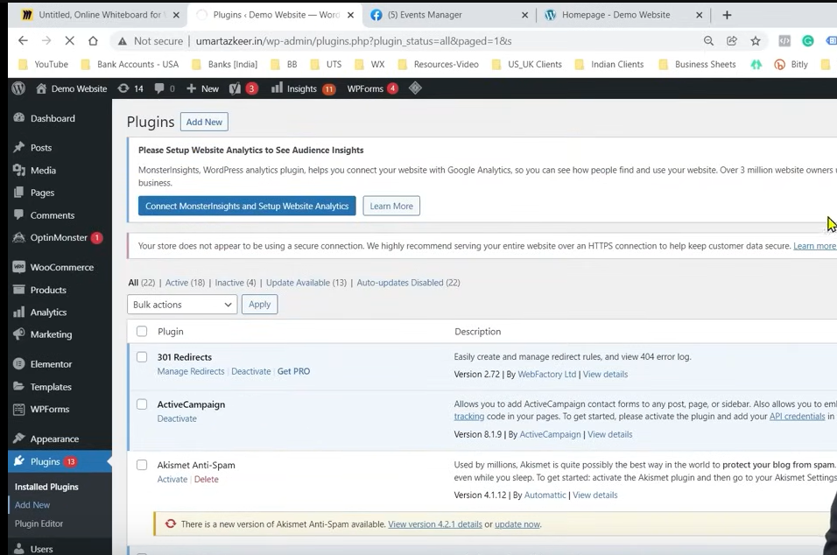

The plugin we are going to use is Pixel your site which is very powerful and popular plugin

Now in side menu you can see your PixelYourSite option

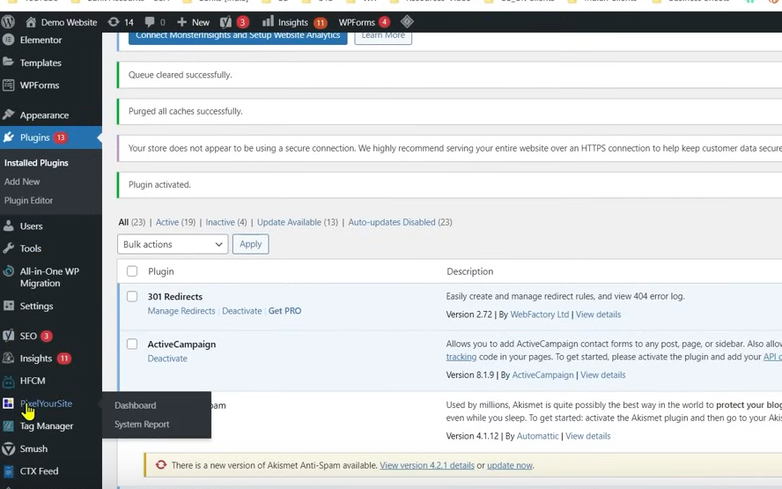

Now go to Pixelyoursite option in your sidemenu and teacher is not telling us any configuration related to it We will see only the things required to setup our ecoomerce event

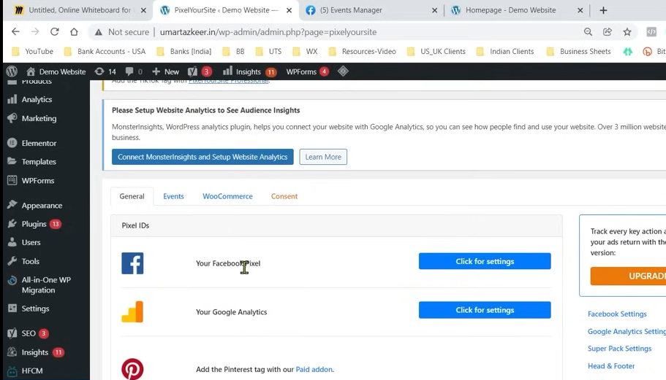

We want to add Facebook pixel so for that we click on Click for setting and then it will be expanded

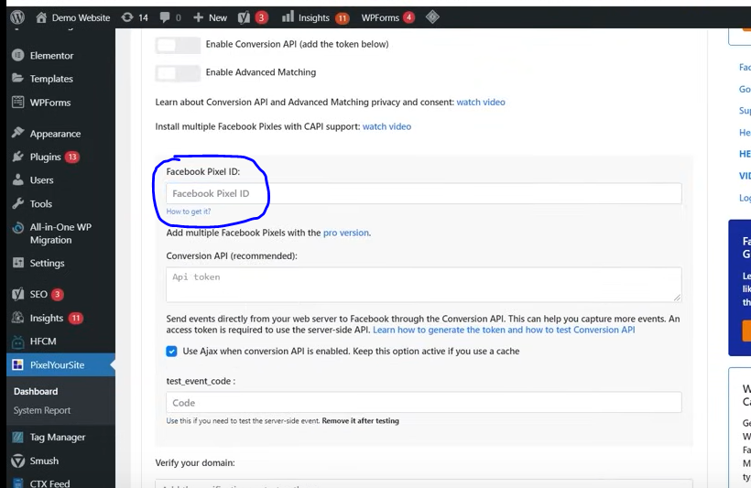

Now in facebook Pixel id mention your facebook pixel id as marked above

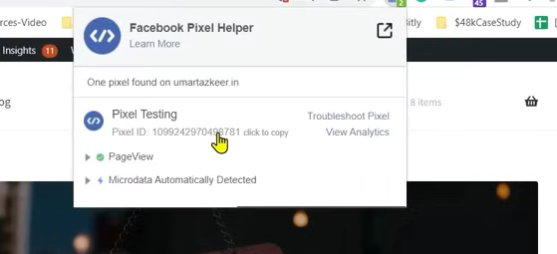

You can pick it from Facebook Pixel helper or you can go to Event Manager

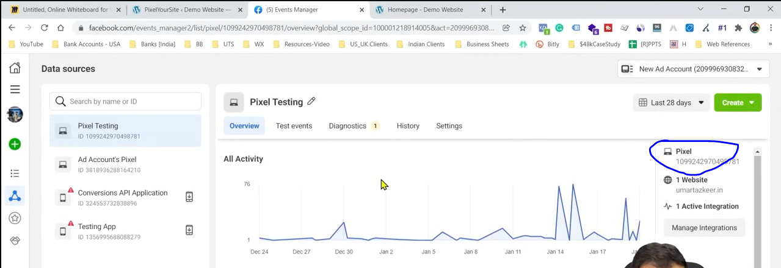

And now in marked above see the pixel id from marked above . Now go below

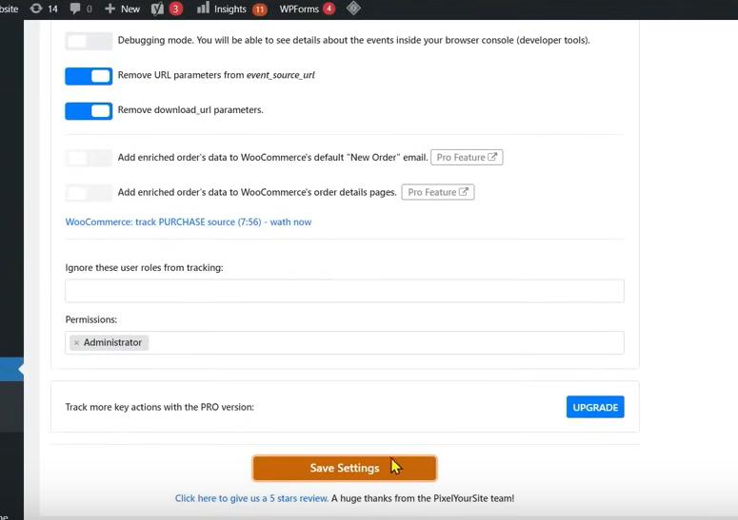

Click on Saved Settings

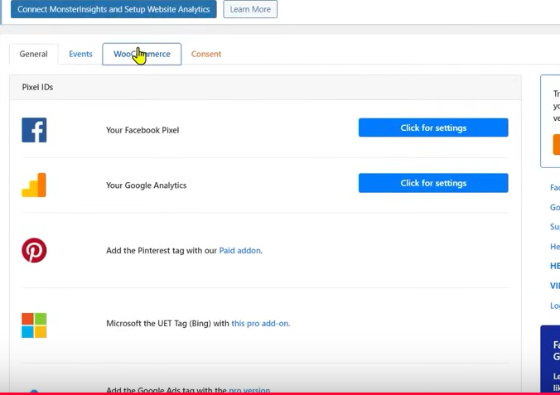

Now you will reach to the first image now click on Woo commerce tab because we want to track woo commerce based ecommerce events

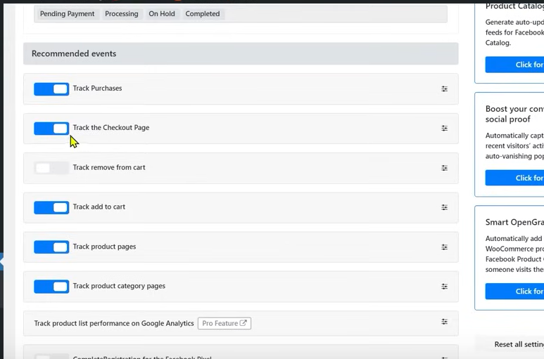

Now in new page keep the below checkboxes checked

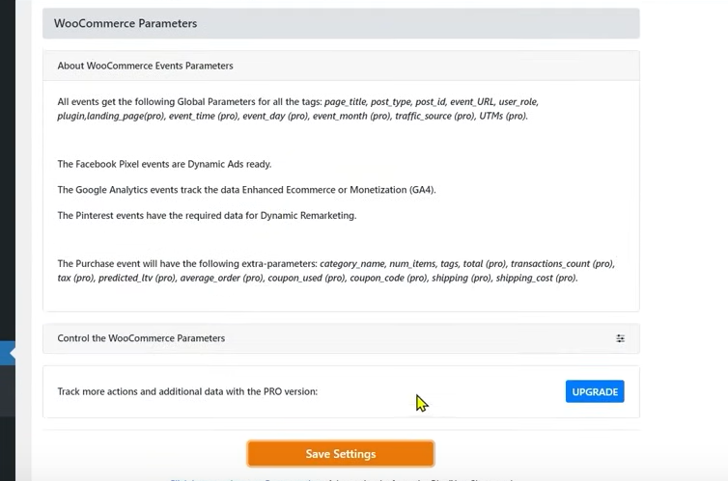

And then now click on Save Settings

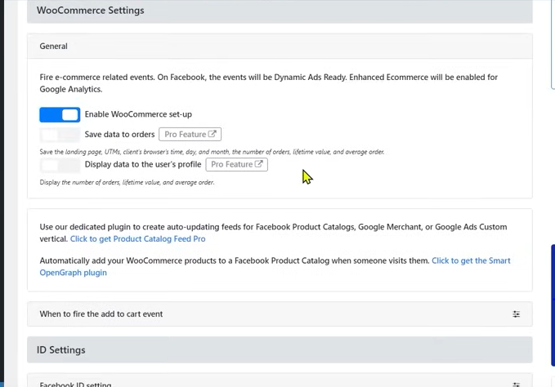

Now check the Enable WooCommerce setup checkbox

Now we will reload our website that the ecommerce events are being fired or not

Now if we see the product page and then check the Facebook Pixel helper

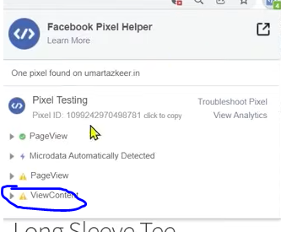

You can see ViewContent as marked above

Now if you click on Add to Cart button

But you can see there is warning symbol beside it which means it is not properly configured here

It is being fired but not configured It is shaowing configuration error because we have no made Product catalogue here When we made it then these errors will automatically got vanished

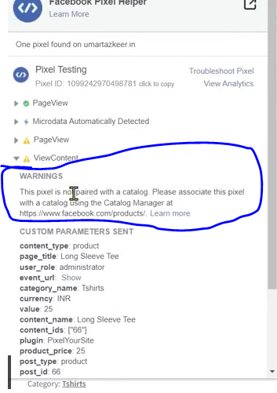

You can see the error message as marked above

The catalogue will be added to the catalogue manager in Facebook So whatever products are present in our website unless the information of all the products in our website in the form of feed does not go to our catalogue then it will not get synched, means unless the information given in the website and the information in catalogue the events will not be configured properly

When we build our product catalogue then this events will correcty start working

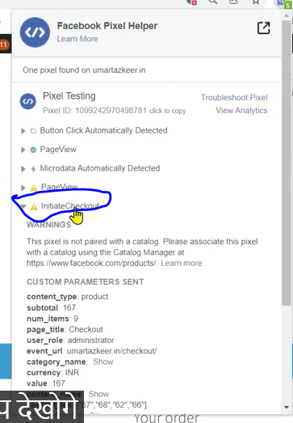

And now we checkout then in pixel you can see Initiate checkout event is given above as marked above

After the page is fully loaded then the event is shown in pixel helper

If you order the product hen you can see order purchase event as marked below

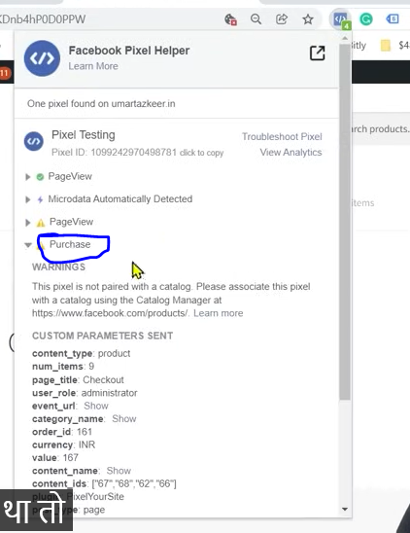

So we will see the whole ecosystem of ecommerce one by one

We will also see how to run Ecommerce based ads

**Phase 83**

It sends a lot of information to the facebook ecosystem It tells the categories in which you buy something you can see from the marked below

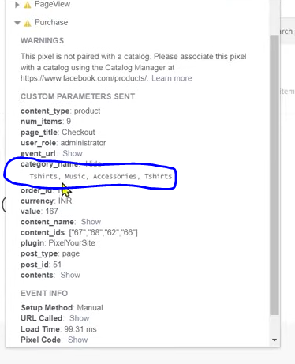

We know that the product 9 is product but facebook don’t have that product in the catalogue so it does not match with the item sent from pixel in website(maybe) In this lesson we see plugin based ecommerce setup and in next we will see how to do it in GTM way.

**Lesson 64:-**

In this lesson we will learn about **Facebook Ecommerce Event Setup**

We will see how to set up these ecommerce events in a website not made of Wordpress but a custom website how we can set up by GTM

In GTM there are two ways to theough which you can integrate ecommerce event in your   
Teacher is showing a website made from wordpress but we will not use any plugin this time

We want that the information of watchcontent, Add to Cart , Intitate checkput to our facebook pixel

Since there are two ways

One way is by using custom codes or events snippet or event pixel given by facebook we can setup our Ecommerce events

In facebook generally we have two types of pixel one is Basepixel that is pageView event and event pixel whoch get fired whwn a certain condition is met

We will fire our event in certain condition

Second way is by using facebook pixel which we get in GTM

There are another advance way which we will see in the future

If you don’t understand this then you will not be able to understand Enhanced Ecommerce based thing then you cannot understand this thing you cannot understand them, parameter based thing , the dynamic things we send to our pixel and you will get problem in understanding data layer at the end of this lesson you will understand hat if we do this by this way then we have some limitation

SO teacher is teeling us every thing so thtat our base becomes strong

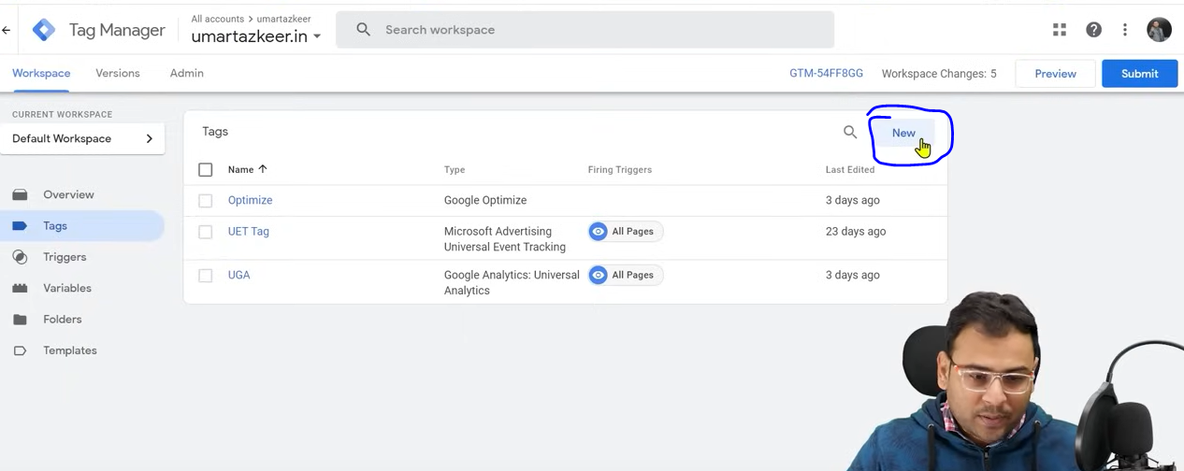

Now we reach GTM and then click on new as marked above

Then below page will be shown

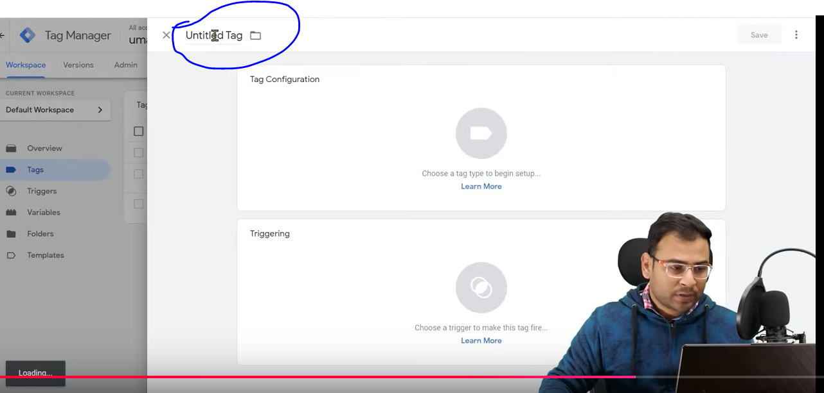

Name the tag in the marked above area

Click on Tag configuration box a sidemenu will open and now choose Custom HTML

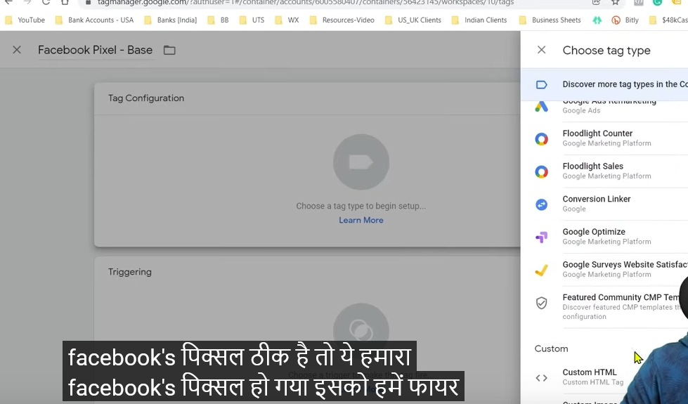

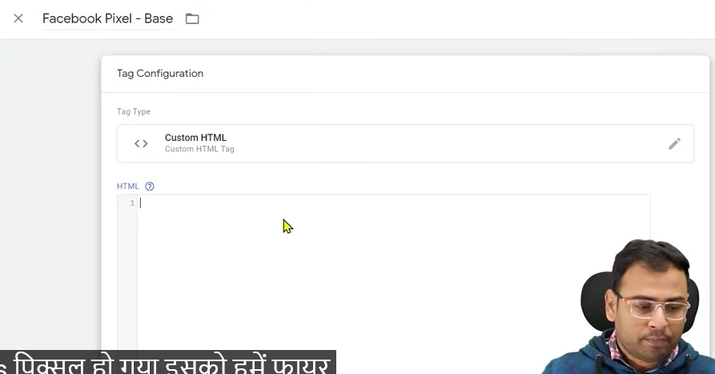

Now we will get the code from event Manager and paste it in above image Textfield

WE log into our event manager

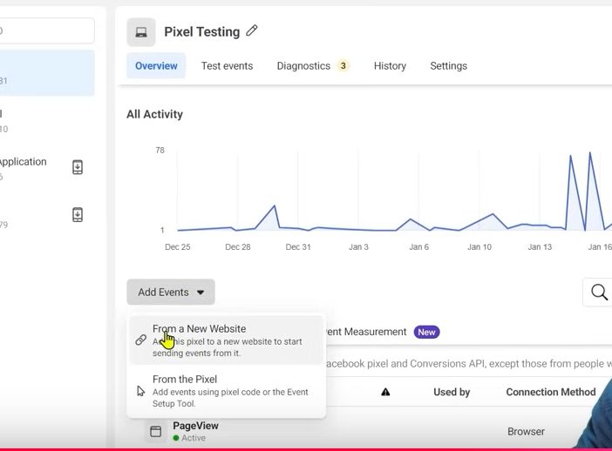

NOw in Event Manager Go to Add Events and then a submenu will be opened and then go to From a new website

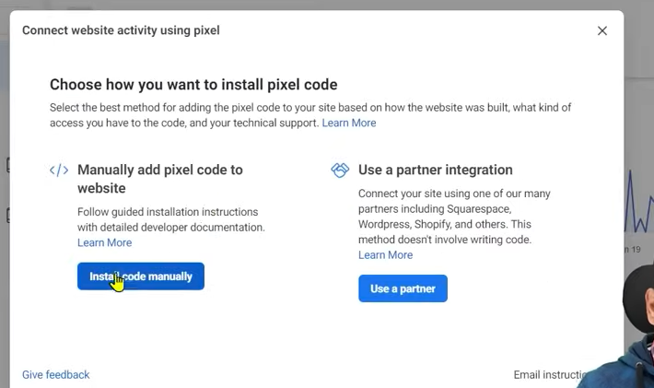

Now a click on Intall Code Manually

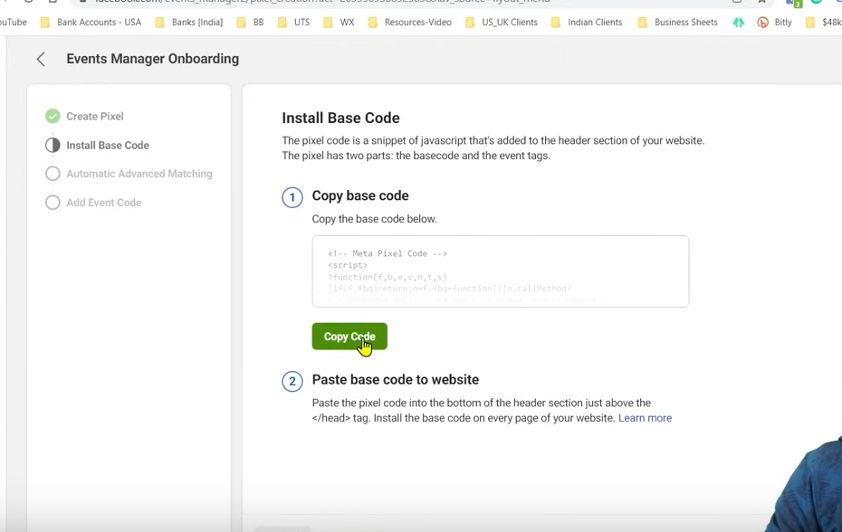

Now click on Copy code This is our base. Now paste it into out GTM Textfield as ahown previously

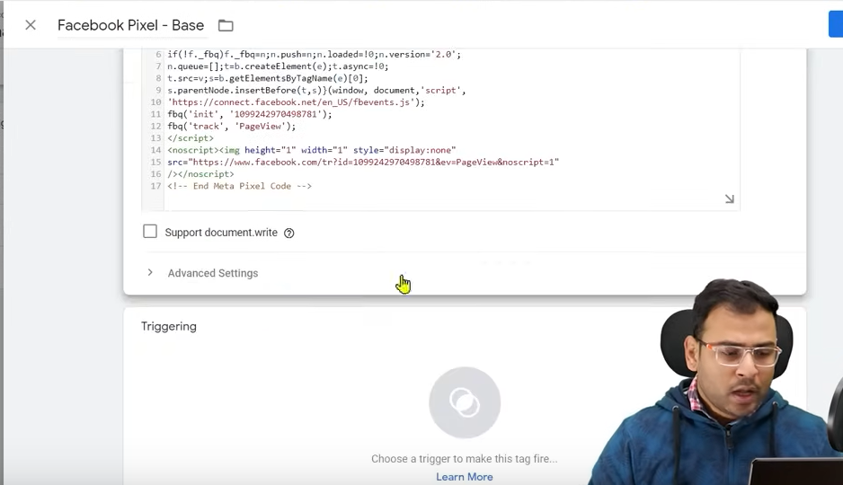

Click on Triggering and the a side menu will be opened

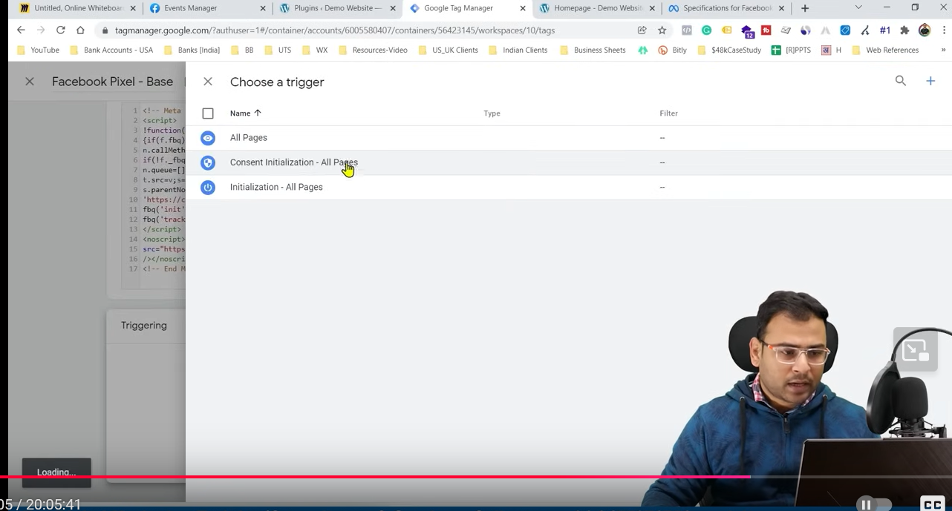

Click on All pages

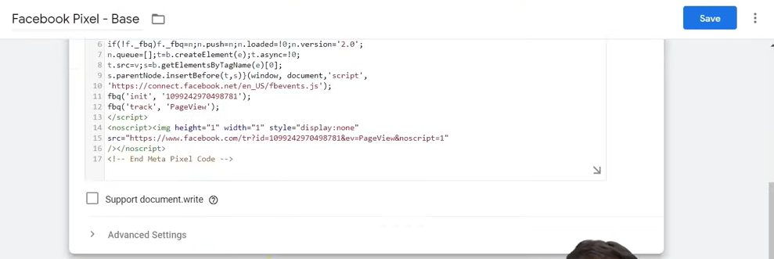

And now click on Save button

By this our code will be triggered for all webpages present in our website.

If we want to fire our event pixel

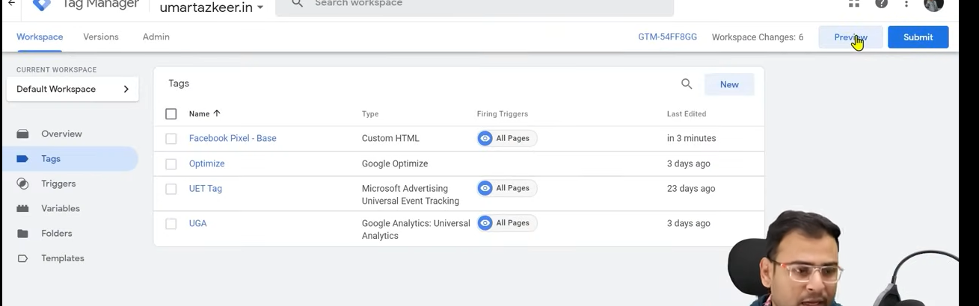

You can see the preview by clicking on the perview button

If we want to fire event pixel then we need to understand that there should be base pixel already present in our website

Withour base pixel it will not work

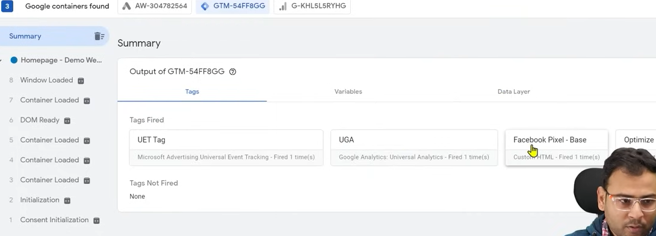

Now in GTM you can see that In above Facebook base Pixel is being fired

I you see in GTM preview it Is being fired(who knows)

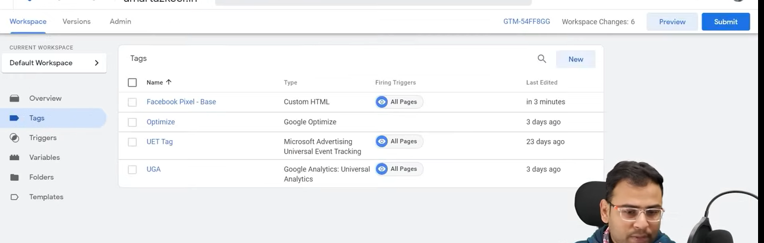

Now click o Submit button

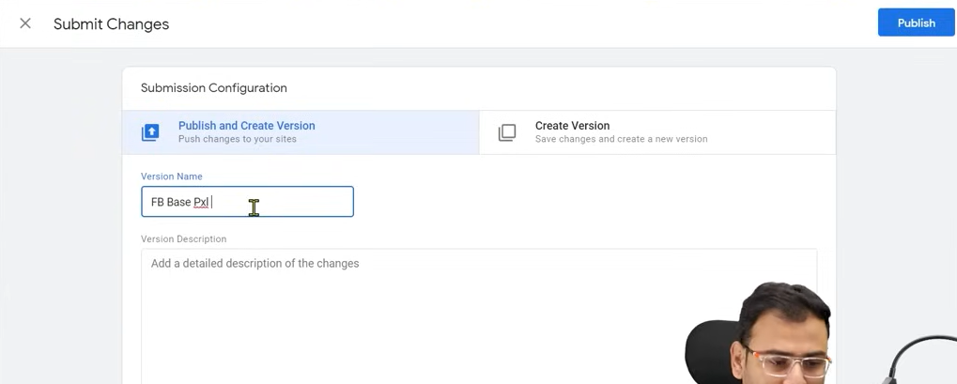

Type the version name and now click on Publish button

Now our container will be live and our base pixel will be set up in our website

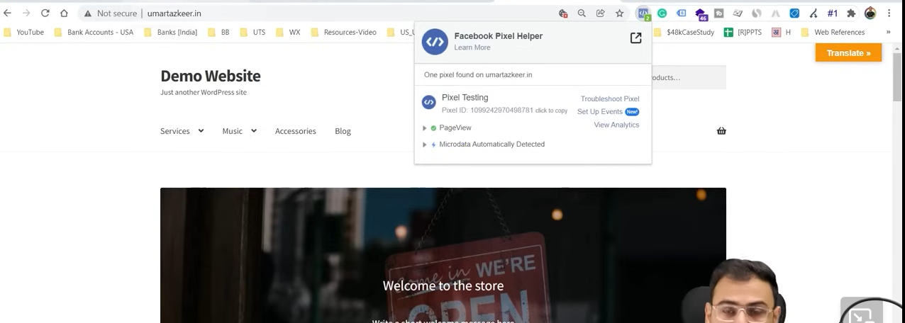

Now you can see pageView pixel is shown in Facebook pixel helper and the pixel is sending the data to facebook but this is not our requirement Our requirement ContentVIew event, purchase event, add to cart event , checkout event

As teacher has said that with base pixel facebook also give you different different event pixel

You have to keep this even pixel in places wherever this condition is being fulfilled and thse thing will be counted in event manager

If we see facebook official documentation

If we see purchase event

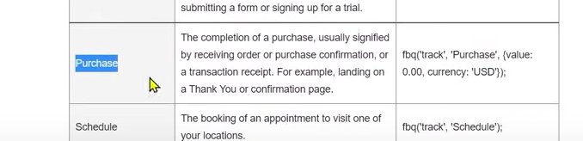

We need to fire the code in the third column of respective purchase row

We need to fire the code on the page or condition where the purchase condition is fulfilled

After this facebook can track that the purchase has happened

Similarly we can say this for our checkout event

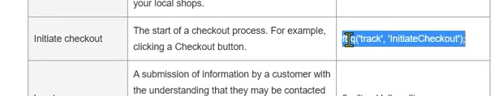

It will be better you put these code between the script tags WE need to fire checkout code where initiate checkout is going on it can be a page or

Now we again go to our GTM and create a new tag and name it according to its use

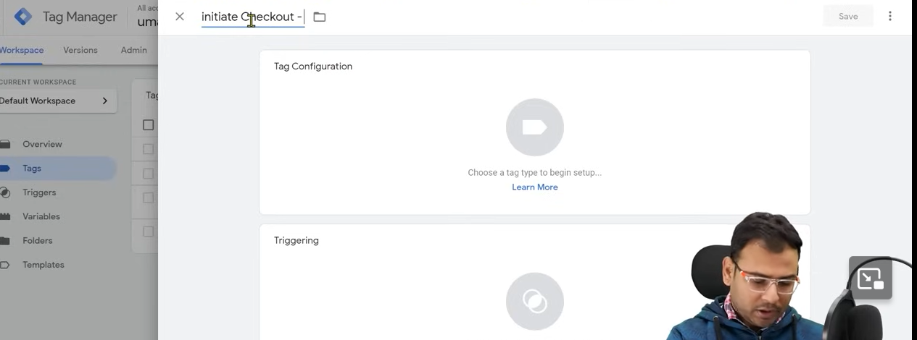

**Phase 84**

We again choose custom HTML

And now paste the code here

Now in Triggering

Make your custom trigger by clicking on + sign as marked below

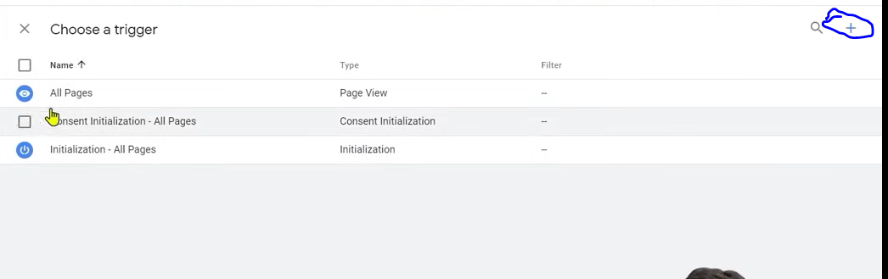

We want to set a triggering representing page which get reloaded and tells about that event happened so for that we make accustom trigger

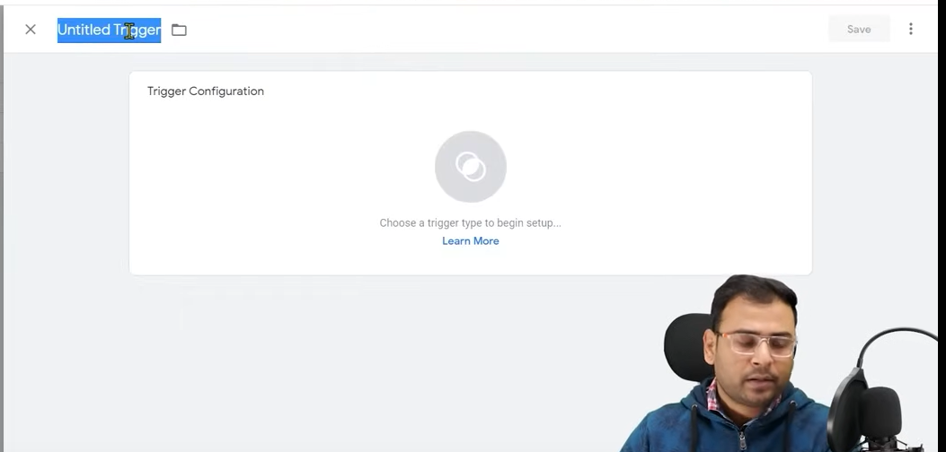

Ow click on triggering configuration box and then a submenu will be opened like below

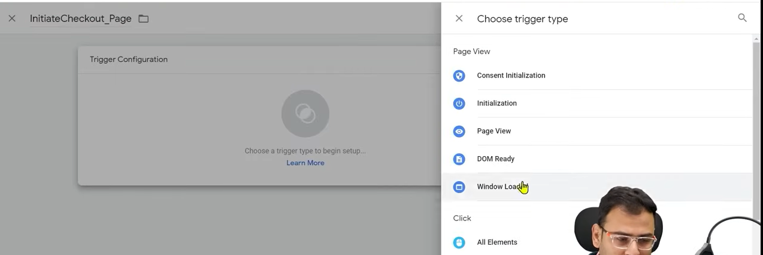

Here choose Page View

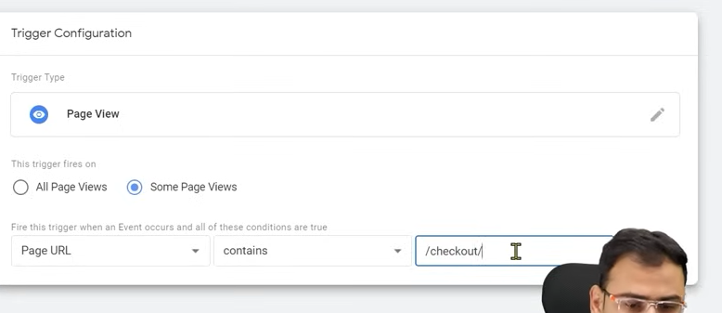

DO the above configuration

Now click on save

You can even match a full url by choosing equals in place of contains

So above we are basically setting the condition so that the tag get fired

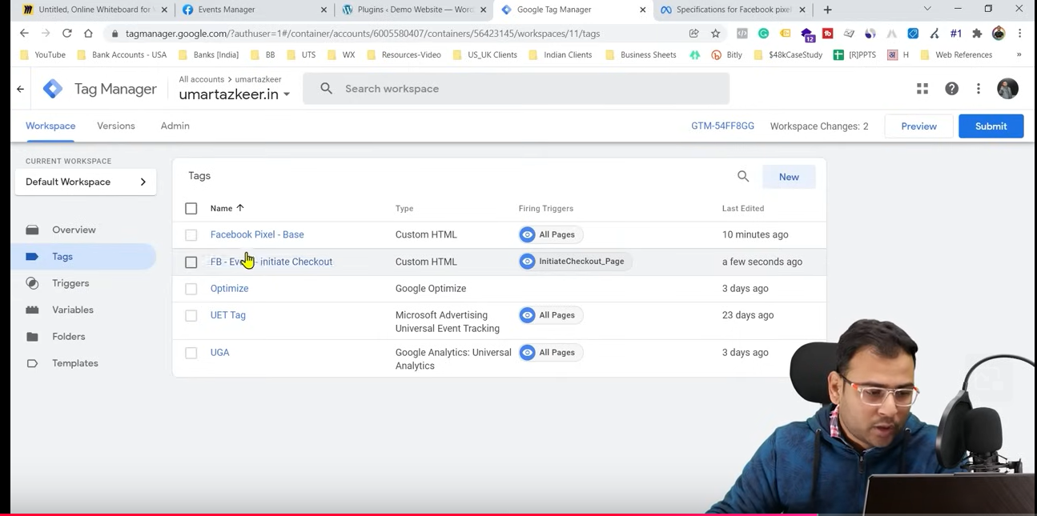

Now if we go to tags then your initiate checkout may be listed here.

So now we check its preview debug

Teacher go to two pages but not to checkout pages

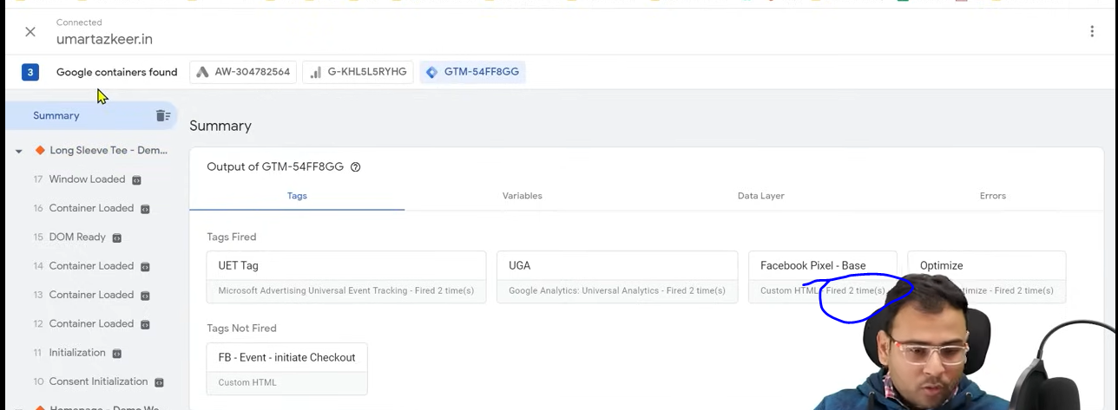

You can see the base pixel is fired two times

(Tag assistant is recording all )

The teacher click on the Checkout button and reach checkout page and he see the result in Tag assistant

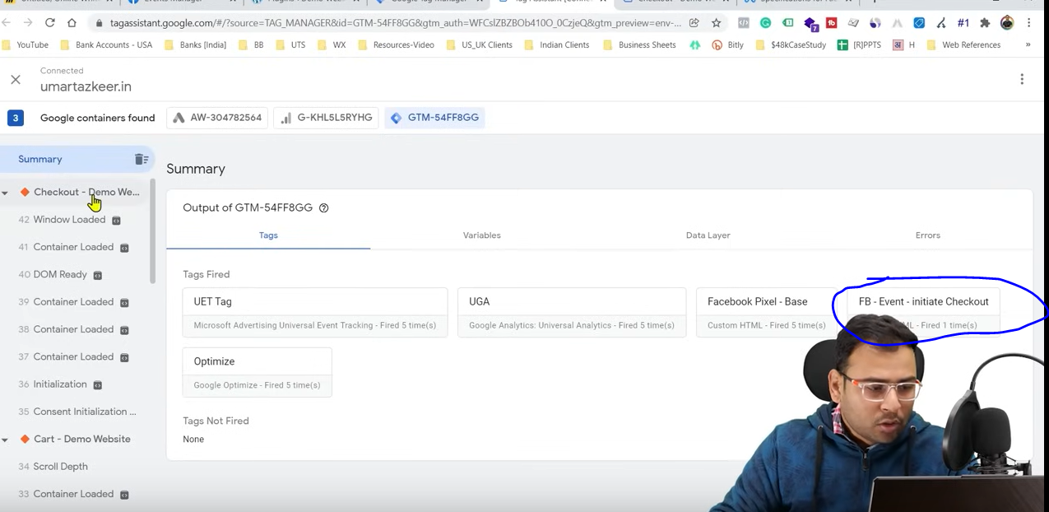

You can se above that Initiate checkout tag was fired as marked above.

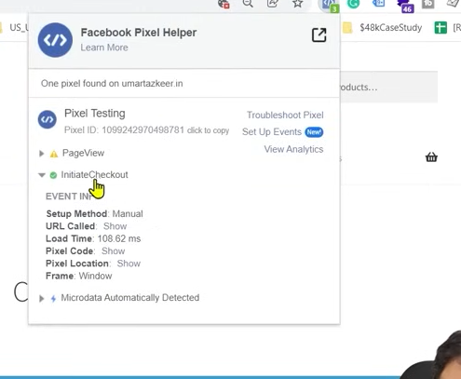

You can also confirm from pixel helper

Similarly for add to cart we can do same ‘

You can see all the statistics in the Event Manager

Before firing event pixel the base pixel should be fired then it will not work

For that you can do more things like when you go to gtm

And you make Event tag then go to advanced settings

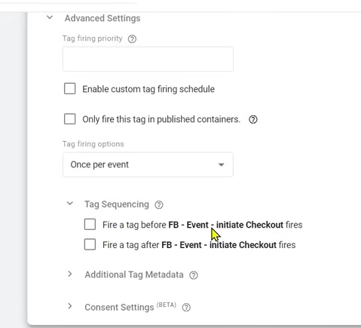

Check the checkbox FB-Event-Initiate Checkout it will be expanded

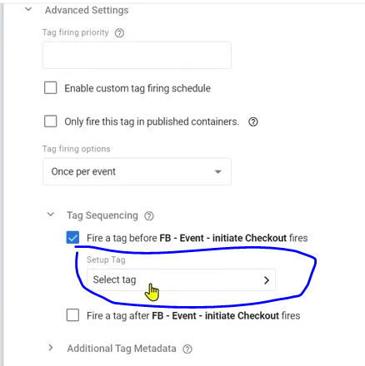

Now click on the select tag as marked above

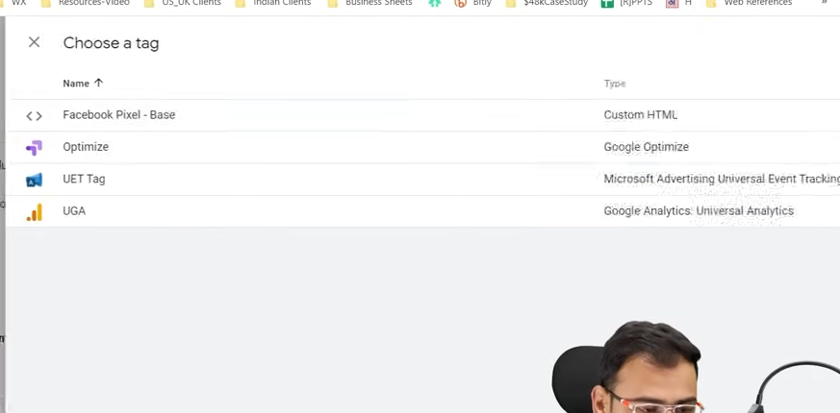

And then a sidemenu is opened choose Facebook Pixel –Bse tag

Save it SO configure it

SO this is the way the teacher has told that we have custom code given by facebook and you need to fier them in different condition but it has a limitation

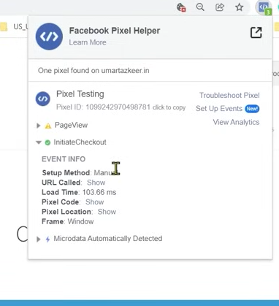

The problem that it is recorded that initiate checkout happened but with that we are not getting the information that whatever product was checkout what was its ID, what is its currency How much amount was checkout these information we are not getting here in the name of eventinfo we are getting tht an event has happened and its name is initiate checkput and it has happened on this condition that’s it What product was checkout pixel don’t know about it and it does not event know the monitory value of it. To set up it for that in our data . layer(event information maybe) should contain the ecommerce based data This is complicated. It simply means that in our data layer should have enhanced ecommerce based things setup

NOw if you go to Tag assistant

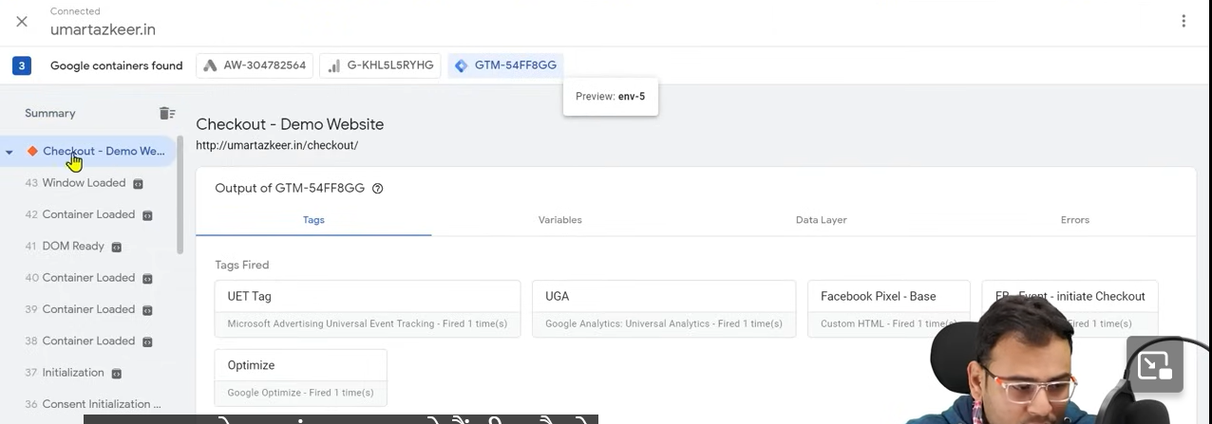

Then in variable tab and Data layer tab is empty as shown below

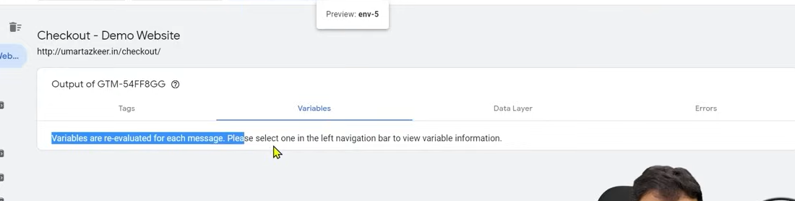

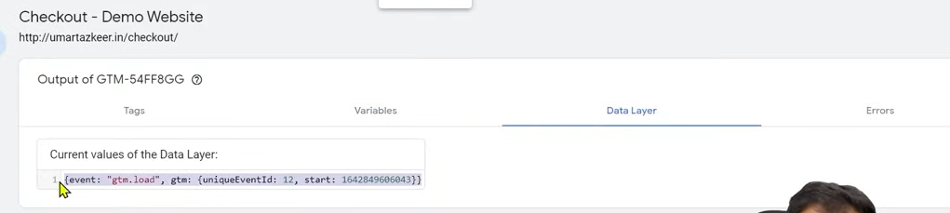

In data layer we want that there should be currency , there should be value of that product

Until we does not get information in our event we could not send this information to our event manager so if we talk about ecommerce setup then our setup is not complete

TO get data of event you need to set enhanced ecommerce setup

To setup enhanced ecommerce set it depends on the website whether t custom or made by CMS.

If your website is custom then 200 percent you will need help of developer and if your website is made by wordpress then you need a plugin and inside wordpress website you send data the teacher will tell us later

Even with this setup if want to run our ads then we will not face any problem that our ads will not run but still if we want to setup dedicated ecommerce based setup then we will say that our information is incomplete

The other way to set up event is by Template of Facebook pixel means if you don’t do above things then in that particular case How you use facebook pixel template

Don’t do both the ways simultaneously

While creating tag an then going to tag type

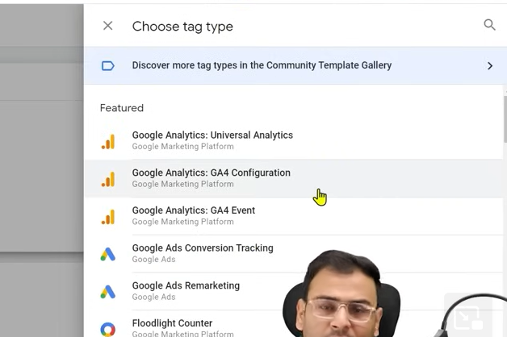

We get some template for our tag but no facebook template is given

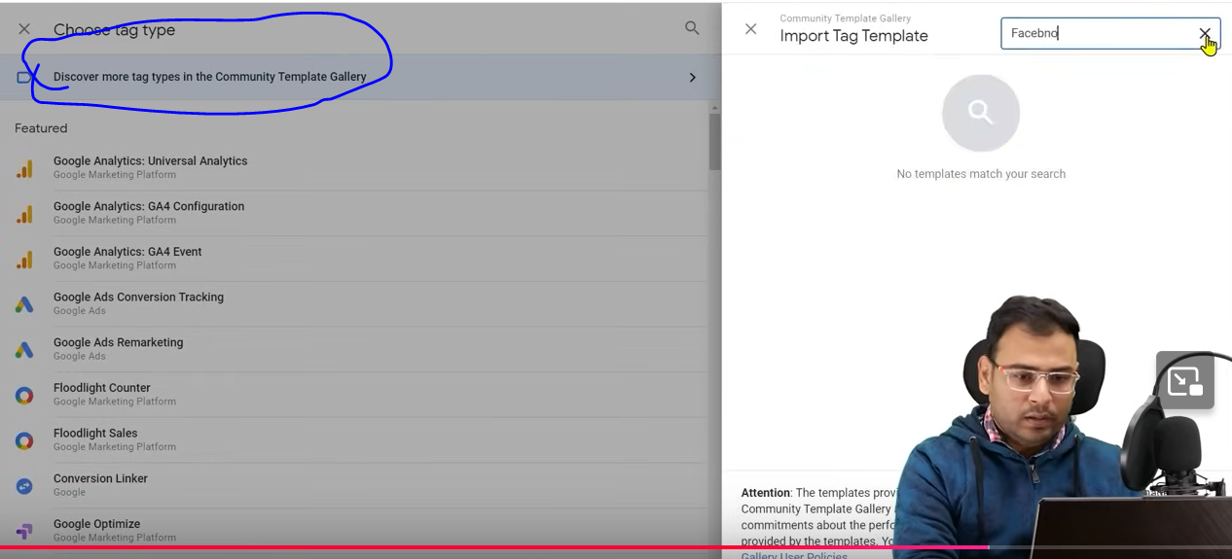

Now click on above marked area then it will be expanded sideways and then in right side search for Facebook pixel

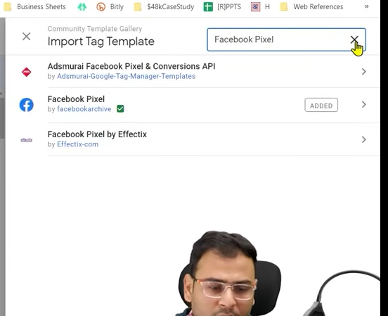

After searching add it

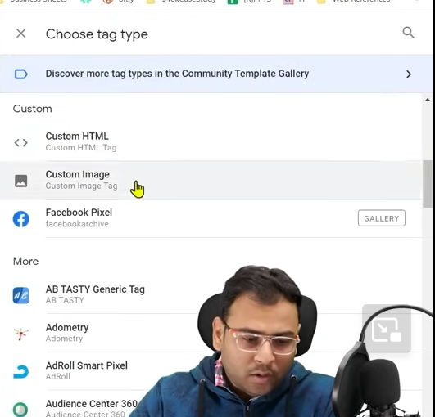

After adding you can see it in tag type

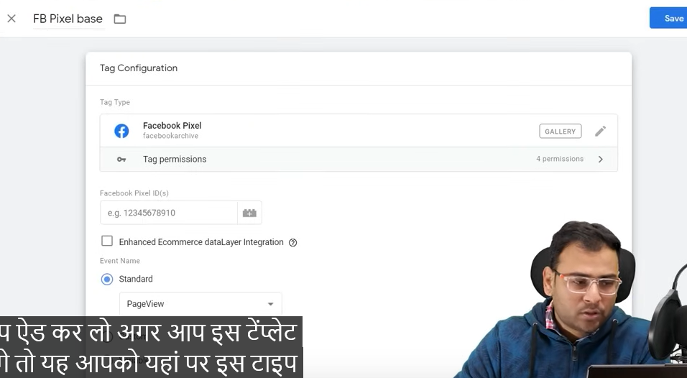

Now afteryou can click on it you will see above

Name the tag you want

Now you don’t have to type code here

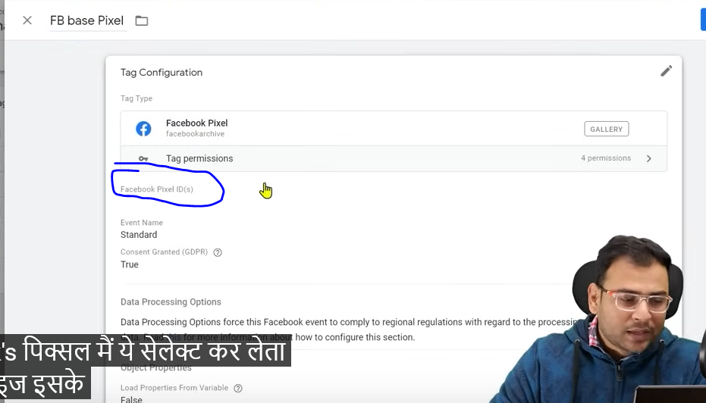

Just click on the marked area

And then it will be expanded

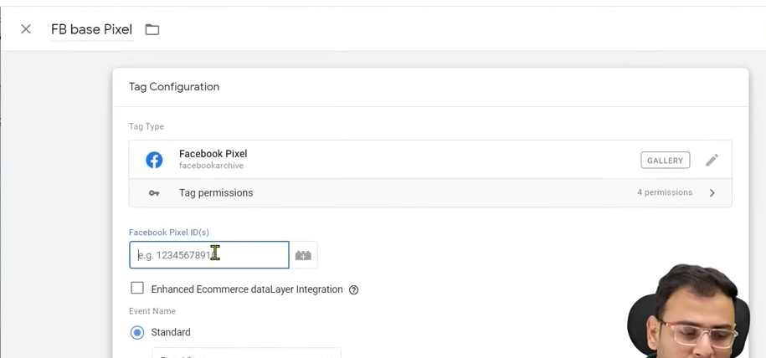

Just type your pixel id I the field as shown above.

**Phase 85**

you get this pixel Id from event manager and now

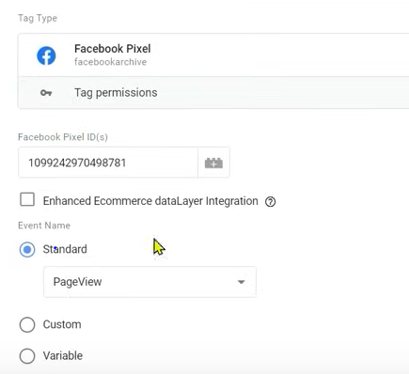

In Standard choose pageView as shown above and then do triggering for all the pages

So in this particular case our base pixel is added here So we don’t have to type the html code here. You just need a pixel id

Now if you want to add event pixel here then what we can do

TO not have to write the is again and again you can save them as a variable

So to do it

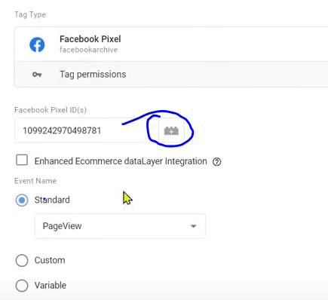

Click on the marked area

And now a new window cover the page like below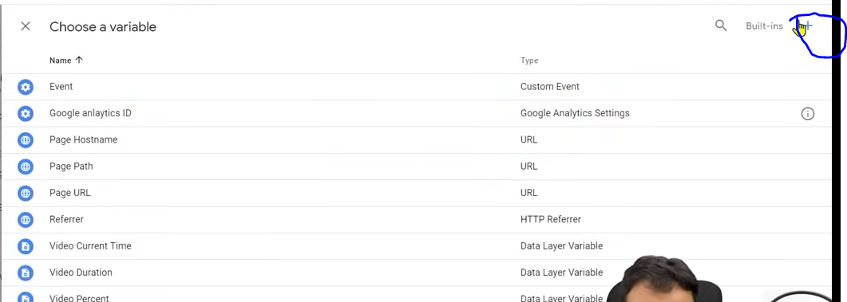

Now click on the marked above

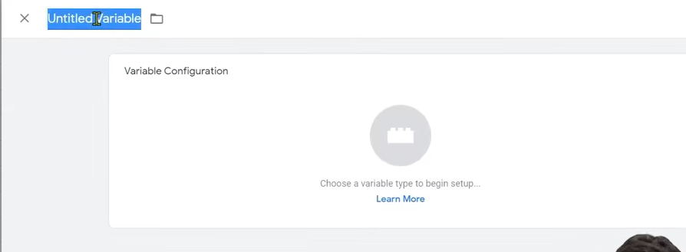

NOw in the sidemenu type the variable name

Click on the variable configuration and then a sidemenu will be opened

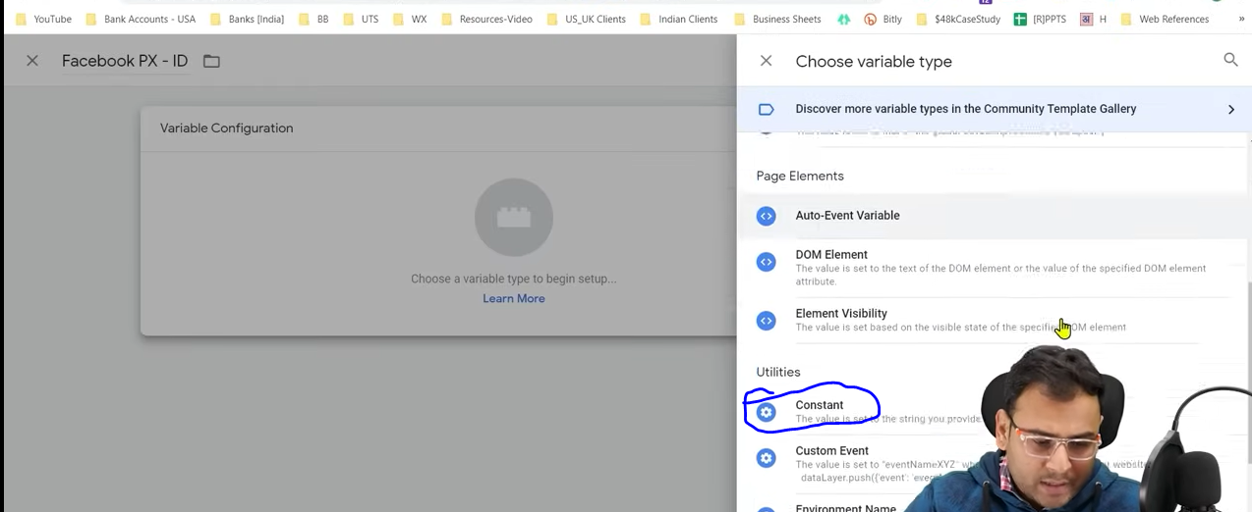

Choose constant as marked above

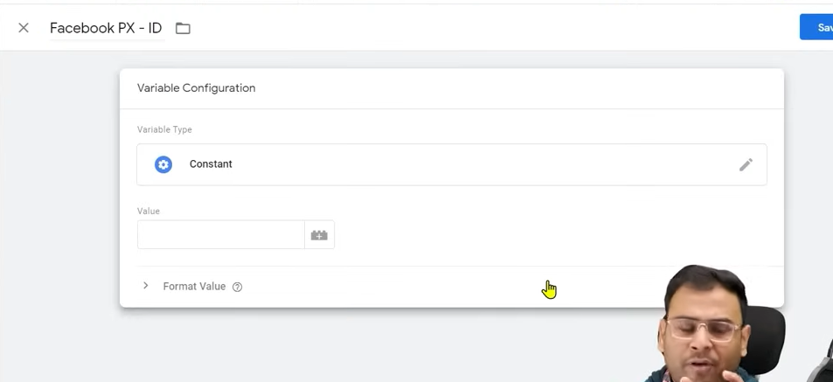

Now type the id in the Value field

Click on save button

Now instead of writing it repeatedly we can click on the marked below and



a sidemenu will be opened



Find the your variable containing your id

Previously we were bringing the code from facebook and then pasting it

Since we are using a template we will choose the option for your event from standard option uppose we choose Initiate checkout as shown below

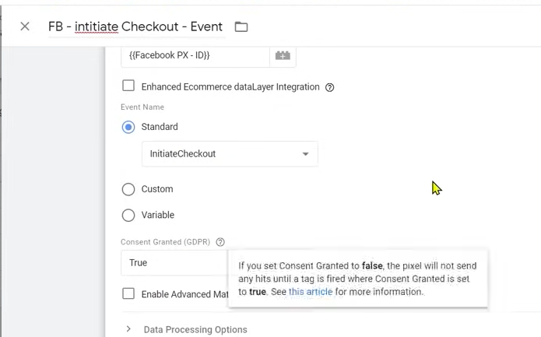

And in triggering we will choose our initiate checkout we created earlier we will save it

It was all about how it happen but there are still some information which has not gone to the Event manager like product related information

For that we need to populate some information in the data layer

To populate that information we need to understand what is enhanced ecommerce

And when you will understand it then you will understand how we get the product related information in variables.

We need to populate that information in our data layer

If we have wordpress website then how you can populate ecommerce data here in data layer.

We are doing this so we can see that how our data will look in our data layer.

In custom websit these things which we are going to see is not valid

In custom website with the help of developer you have to put code in your website

It is sur understand that custom website is made by developer Marketer does not made it

There are codes related to marketing that you have to take the help of developer as a marketer you cannot do it you have to understand this thing

AS a digital marketer what to tell the developer If you cannot tell the developer what you need then there will be problems

Teacher is showing what we want

We are achieving this through plugin but if we want to achieve it through developer then how will we do it

There is aplugin called **GTM for Wordpress**

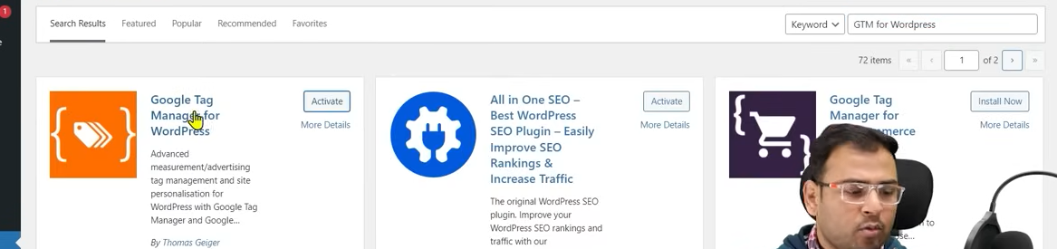

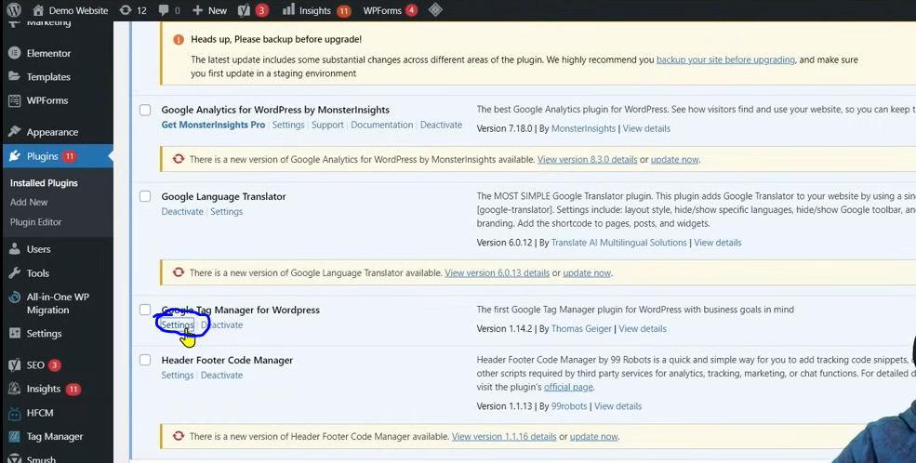Now to plugin and got to its plugin setting by click on marked above

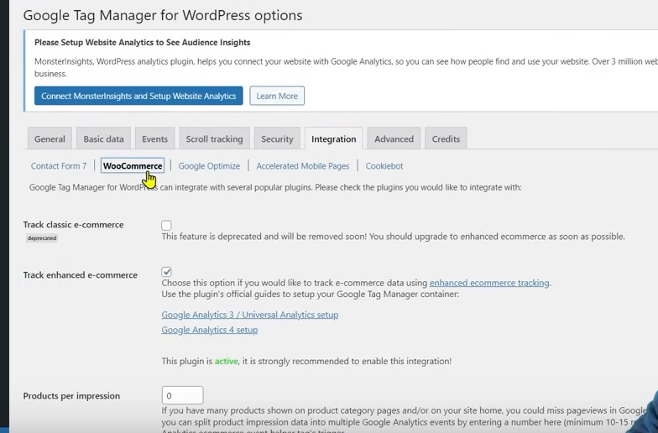

So we go to Integration and then to Woocommerce as shown as bolded above

Make sure the track enhanced ecommerce checked

It is keeping the tracking of enhanced ecommerce on

We do it by plugin but in custom website there is no plugin so it will be done by the developer   
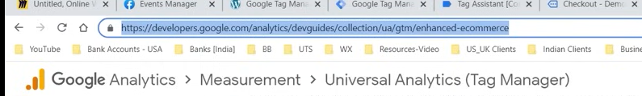

Follow the ebove link is highlighted (I think type until devguides)

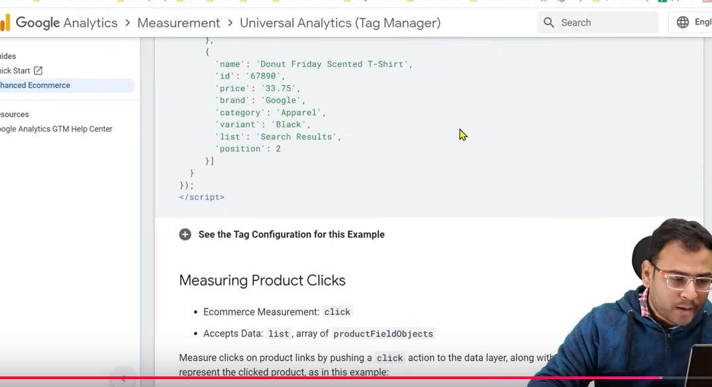

And here you see the code lets suppose we Want to track purchases then we copy the purchase code from here similarly for add to cart you need to paste this code in the area where there is a purchase or add to cart

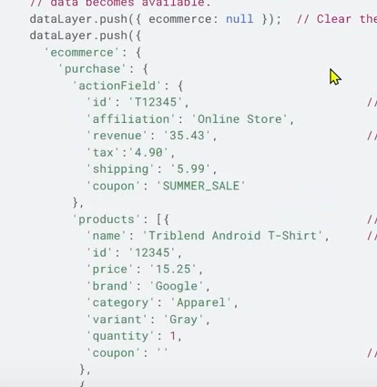

And now developer will not the field like id ,affiliation as it is how will dynamically fetch it

If there is purchase then what is there is id, amount developer set it dynamically we all are doing it through plugin these information will come inside data layer and the above code also says dataLayer.push

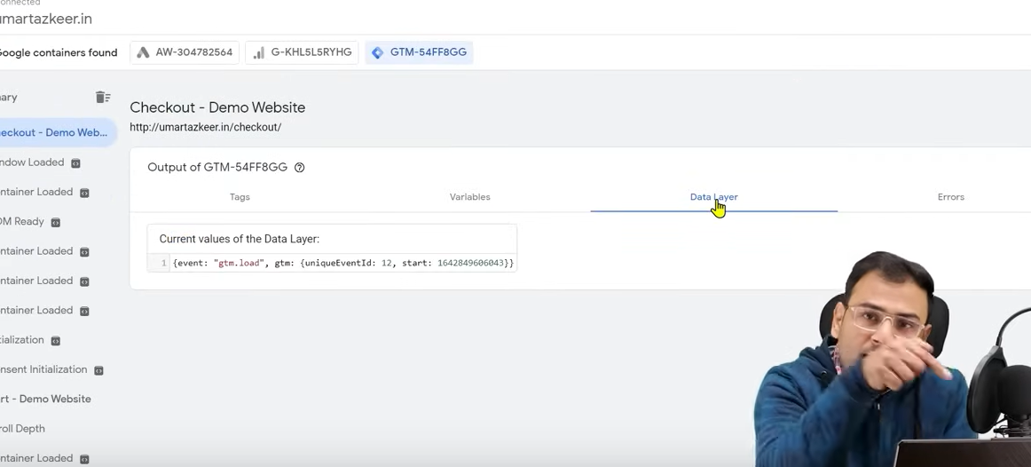

The information is need in data layer as shown above

Until we does not get the information we could not use it in event Manager

To do all this we need to enhanced ecommerce

You have to tell the developer that put this code in the condition when event happened or a page whose load is counted as an event completion and change thing dynamically for parameters0020

Even in the link we given above there is proper documentation how to do it.

What you have to do is that the event useful to you have to pick them like purchase initiate checkout you can confirm it by checking that is there any data populated in data layer We do all the work through plugin

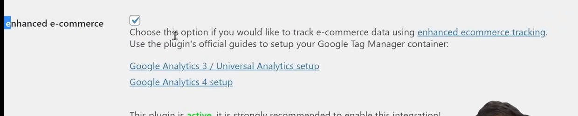

If you read the text of checked checkbox then it is written as shown above